**Velmex: Procedures**

* Turn on the computer and the power button on the circuit breaker
  + Make sure the VRO box has the word “set, start, set” in that order.
  + Turn on the light and position your marked core so that the **oldest** rings are directly underneath the microscope
    - Make sure the stage is set up so the crank handle (used to slowly slide the stage) is to the right of the microscope.
      * If the stage is not setup correctly
  + Load both the programs MeasureJ2X and AmScope
* Select MU550 in AmScope
  + Make sure the lighting is good enough to see the core, and adjust the focus so the core is clear
  + Now that the core is clear in AmScope it will be blurry if you look through the microscope’s eyepieces so for now focus only on AmScope
  + You may need to adjust the stage.
    - To do this shift the metal switch to the right and move the stage freely
    - Once you have the stage properly positioned click the switch all the way to the right so it is locked in place
  + Grab and drag the small arrows in AmScope found in the left corner so that they make a target (see two images below)

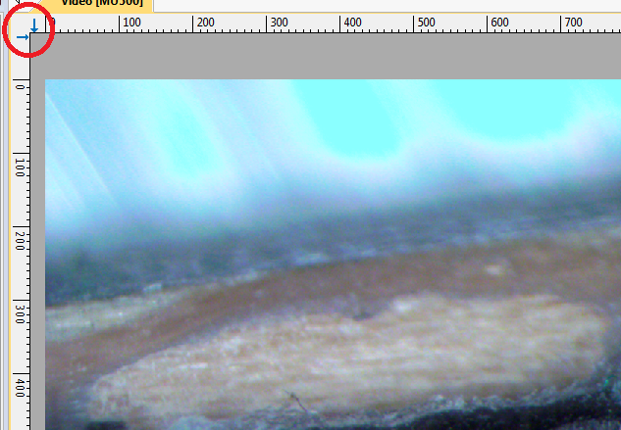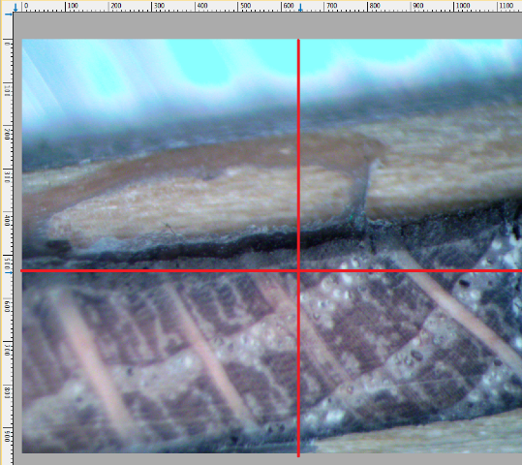

* + The target does not have to be the exact center of the screen, but it should be close. This target is used to measure the length of the rings as a point of reference ONLY, it does not actually measure anything it’s just a point of reference for you while you measure.
* Press the “Start” button in the middle of the Velmex VRO display
  + The display should read 0.000 mm. If it does not you will need to do some trouble shooting using their website <https://www.velmex.com/Products/Controls/VRO_Encoder_Readout.html>
* Click into Measure J2X
  + Click the Setup tab, then “Measuring system” and make sure it is recording in “Velmex VRO,” and select it if it is not highlighted. Click ok
  + Open the Setup tab again then click “connection” and under “connection settings” make sure the Port selected is “COM4” the default is “COM1” and you will need to change it into COM4 and click OK
  + Now click the “series” tab and “new”
    - In the Series Information edit the Series ID as the tree ID number and input the start year as the oldest FULL ring on the tree. Click OK
  + A new screen will popup in MeasureJ2X, check down in the lower left corner and you will see the Measuring: tab, click “Start”
* Click the C button on the Velmex VRO module to make sure everything is cleared (in case you had to move the stage)
  + Now find the small controller with the buttons “clear” and “send”
  + Push the “send” button and make sure the Initial value (in Measure J2X) is set to 0.0.
  + Click OK in measure J2X
* The target in AmScope should be EXACTLY at the start of the annual ring
  + Use the crank on the right of the stage and turn it so the image of the core on AmScope moves slightly to the right. Watch the value increasing on the VRO
  + Once you get to the next year’s ring use the controller and click the “send” button
    - This value will now show up in MeasureJ2X along with the year
  + Continue to use the crank wheel to slowly move to the next year and repeate the procedure
    - If you need to physically manipulate the core make sure the target is in line with the rings
    - Make sure the target moves PERPENDIULAR to the rings. You may need to move the core slightly as you continue.
    - This can be a delicate and time consuming process.
    - Go **slowly**,
* Once you have gotten to the most recent year click the “Stop” button in Measure J2X
  + Now click the small x in the upper right corner of the Series ID tab. Be careful NOT to exit out of Measure J2X
  + Click “save as” and name the file with the species code first followed by the tree ID number
    - Example – QURU123545
  + Click OK on the save message
* Click the File tab then close to make sure you are out of the current core
  + Click series new if you have more cores to enter